Audit and Review

We offer a wide range of bespoke Audit products to be used as a vital management tool in all aspects of the insurance business. We now have a worldwide network of Audit and Claims specialists and are able to design and implement detailed claims handling processes, evaluate the effectiveness of reserving policies and advise on implementing measures to reduce claims spend.

Both internal and external Regulatory Compliance is now an important part of your business. We can provide flexible solutions to this to meet your own needs. This may involve “best practice” processes, technical conduct, financial performance, data capture and could include service provider comparisons within a fully integrated audit programme.

We offer a unique blend of senior claims management and technical expertise across all levels of the business. Apart from the UK and Ireland we now operate globally with divisions in Europe, North and Latin America and in Asia Pacific where, recently, we have been very active. We provide impartial and confidential advice and support for a host of issues linked to the handling and audit of claims.

Our people cover a wide range of disciplines in insurance including - Property and Business Interruption, Personal and Catastrophic Injury, Products Liability, Professional Indemnity, Marine Transit, Motor losses and Coverholder Audit. Our service is delivered by experienced professionals drawn from loss adjusting and insurance claims practices together with accountancy, engineering and the legal professions.

We live in changing times highlighted, only recently, by the UK Government’s decision on the valuation of personal injury claims. This is likely to result in a review by all insurers of their reserves surrounding new and existing claims. We can assist in this process by working closely with the client to review potentially increasing liabilities.

For further information on the services we offer or to arrange a meeting to review your needs contact:-

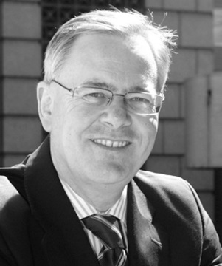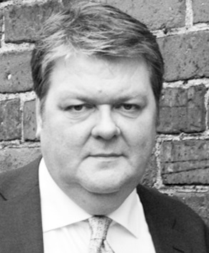

Bev Fitzgerald Graeme Shurben
Managing Director Director
+44 (0)7815 810772 +44 (0)7904 564597
bev@fitzgeraldconsulting.co.uk graeme@fitzgeraldconsulting.co.uk

